Clothing Layers
Infographic of the layering system
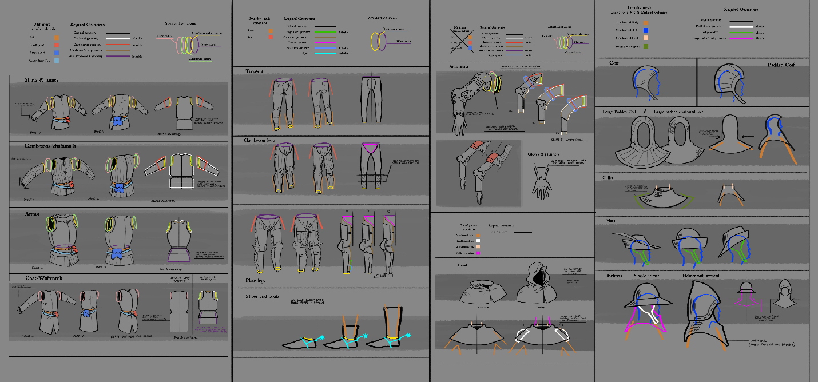
Torso
- Body garment slot
Non-gambeson items
Various tunics, jupons and pourpoints must meet the following requirements:
- Small pouch - hideable geo.
- Large pouch - hideable geo.
- Secondary sword belt. This belt is picked from available secondary belts in macro atlas. It is a hideable geo.
Gambeson items
Various types of gambesons, aketons, padded jackets and so on must meet the following requirements:
- Small pouch - hideable geo.
- Large pouch - hideable geo.
- Feature for chainmails (refer to chainmails for details).
- Secondary sword belt. This belt is picked from available secondary belts in macro atlas. It is a hideable geo.
- Body chainmail slot
Only chainmails. Chaimails do not have their own geo they are just a paintable feature in every gambeson.
- Two skirt lenghts - short and long with feature for endings.
- Two sleeve lengths - short and long with feature for endings.
- Body plate slot
Cuirasses and brigandines must meet the following requirements:
- Small pouch - hideable geo.
- Large pouch - hideable geo.
- Must include gambeson geometry of the most common length.
- Must include chainmail features.
- Other length is achieved via skirt attachment on the waist seam.
- Coat layer
Waffenrocks and coats must meet the following requirements:
- Small pouch - hideable geo.
- Large pouch - hideable geo.
- Three different lenghts of sleeves: none, short, long.
- Must include gambeson geometry of the most common length.
- Other length is achieved via skirt attachment on the waist seam.
- Puffable morph to simulate the presence of cuirass or brigandine.
- Check compatibility with arm armor.
Arms
- Arm armour
Vambraces, couters and full plate arm armour.
- Must include short sleeve coat geometry.
- Must include rolled up long sleeve geometry (attached to short sleeve geo).
- Must include gambeson feature.
- Must include a chainmail feature.
- If there are pauldrons they must have their own feature to by hideable.
- Also, there must by morph to push then over large padded/mail coif.
- Standardized length and ending to fit into the gauntlet opening.
- Gloves
Leather and gauntlets.
- Wide opening to accommodate arm armor.
Legs
- Hose slot
Non-gambeson types
Different types of hose.
- Unified ankle seam.
- Unified hip seam.
- Volume for skirts
- Volume for knee high boots.
Gambeson types
Padded legs and hose must follow these requirements:
- Unified ankle seam.
- Unified hip seam.
- Volume for skirts
- Seams for variable geometry for boots of various heights or volume for knee higgh boots. Depends on thickness of the padding.
- Leg Plate slot
Birgandine, mail or plate leg protection, must follow these requirements:
- If not completely enclosed they must have feature for ankle and knee-high "tucked-in" boots.
- If they do not have a sabaton (attached metal shoe) they must fit on the ankle seam.
- Separate model for chainmail protection.
- Boots slot
Boots, shoes, leather soles and so on.
- Three different shoe sizes. Low-cut, ankle-high, knee-high.
- Cut to three different features respectively to boot sizes.
- If you wear armor without a sabaton, everything from ankle seam up will be hidden and in plate legs an appropriate boot feature will become visible.
- All boots must have a hideable spur geo.
- Spurs
- All shoes must have a hideable spur geometry.
- Feet also have a hidden spur geo.
Head
- Coif slot
Cloth coif, padded small and large and mail coif.
Non-gambeson types
- Just cloth coif
- Exists as a separate geo
Gambeson types
- Large mail/padded coif and small padded coif
- Large ones have shrink morph to accommodate for hood
- Exists as a separate geo
- Collar slot
- Unified neck seam
- Must fit under long padded/mail coifs
- Hood slot
- Morph to accomodate for large coifs
- Has hooded and unhooded variant. These are two different models.
- Helmet slot
Hats and caps
- All sorts of types.
- Have geo for coif - hideable.
Helmets
- All sorts of types.
- Kettle-hats and skullcaps, and bascinets without an aventail have mail and padded large and small padded coif geo in.
- Visored helmets have a standardized bone for the visor animation.

